**OUTPUT:**

**Task 9: Change the billing cycle to Seconds, Minutes and trigger subscription deduct amount from the wallet.**

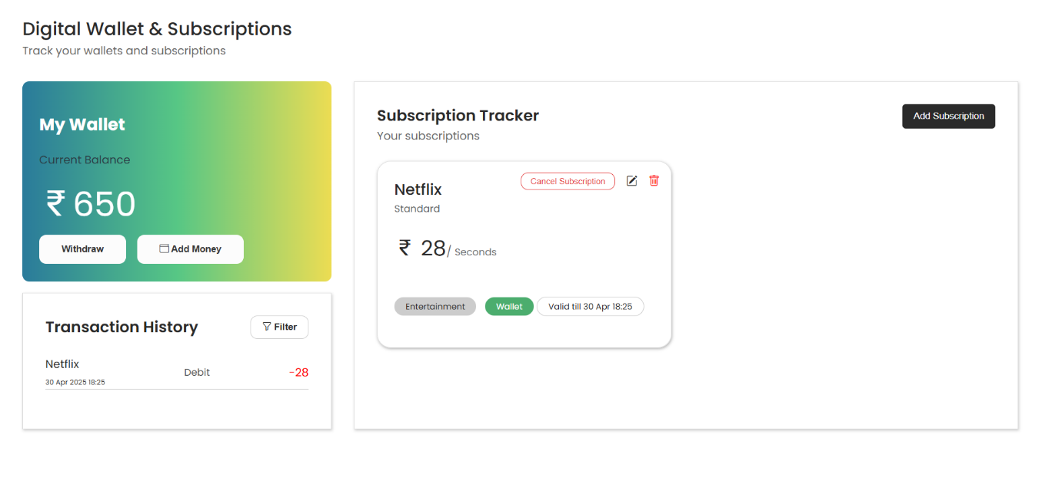

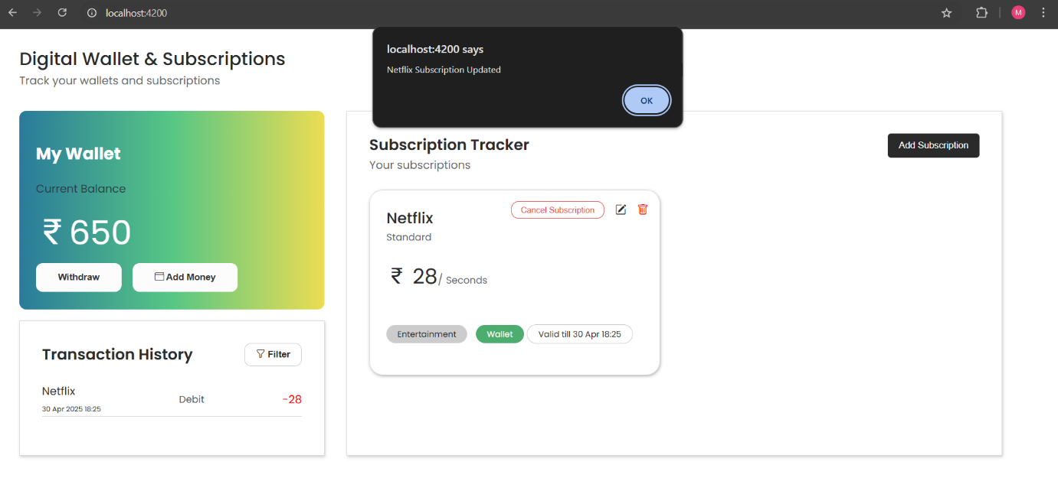

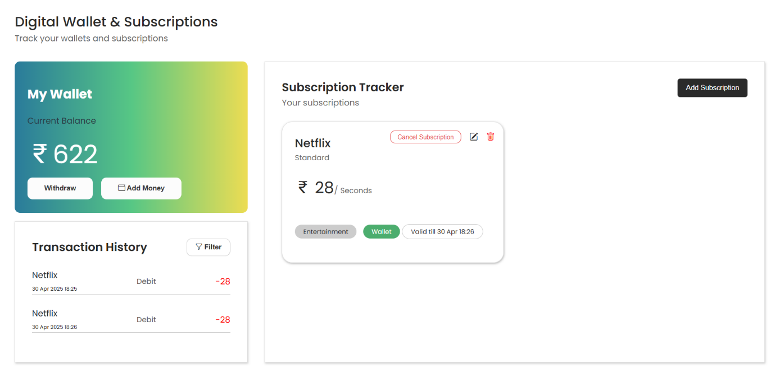

**CODE:**

**Index.html**

<!DOCTYPE html>

<html>

<head>

  <meta charset="utf-8">

  <title>AssessmentApp</title>

  <meta name="description" content="">

  <meta name="viewport" content="width=device-width, initial-scale=1">

  {{content-for "head"}}

  <link integrity="" rel="stylesheet" href="{{rootURL}}assets/vendor.css">

  <link integrity="" rel="stylesheet" href="{{rootURL}}assets/assessment-app.css">

  <link rel="preconnect" href="https://fonts.googleapis.com">

  <link rel="preconnect" href="https://fonts.gstatic.com" crossorigin>

  <link

    href="https://fonts.googleapis.com/css2?family=Poppins:ital,wght@0,100;0,200;0,300;0,400;0,500;0,600;0,700;0,800;0,900;1,100;1,200;1,300;1,400;1,500;1,600;1,700;1,800;1,900&display=swap"

    rel="stylesheet">

  <link rel="stylesheet" href="https://cdn.jsdelivr.net/npm/bootstrap-icons@1.11.3/font/bootstrap-icons.min.css">

  {{content-for "head-footer"}}

</head>

<body>

  {{content-for "body"}}

  <script src="{{rootURL}}assets/vendor.js"></script>

  <script src="{{rootURL}}assets/assessment-app.js"></script>

  {{content-for "body-footer"}}

</body>

</html>

**Templates/application.hbs**

{{page-title "Assessment-App"}}

{{outlet}}

<span class="head-text">Digital Wallet &amp; Subscriptions</span><br>

<span class="head-desc-text">Track your wallets and subscriptions</span>

<div class="container">

    <div class="left">

        <div class="my-wallet">

            <h2>My Wallet</h2>

            <p class="amount-title">Current Balance</p>

            <span class="amount"><i class="bi bi-currency-rupee"></i>{{this.amount}}</span>

            <div class="wallet-btn-container">

                <button class="wallet-btn withdraw" type="button">Withdraw</button>

                <button class="wallet-btn add-money" type="button" {{on "click" this.toggleModal}}><i

                        class="bi bi-wallet"></i> Add Money</button>

            </div>

        </div>

        <div class="transaction-history">

            <div class="transaction-header">

                <span class="heading">Transaction History</span>

                <button class="filter" {{on "click" this.toggleFilter}}><i class="bi bi-funnel"></i> Filter</button>

                {{#if this.isFilterOpen}}

                <div class="filter-modal">

                    <input type="checkbox" value="debit" name="filter-check" id="debit"><label

                        for="debit">Debit</label><br>

                    <input type="checkbox" value="refund" name="filter-check" id="refund"><label

                        for="refund">Refund</label><br>

                    <input type="checkbox" value="credit" name="filter-check" id="credit"><label

                        for="credit">Credit</label>

                    <div>

                        <button {{on "click" this.clearFilter}} class="filter-modal-btn">Clear</button>

                        <button {{on "click" this.applyFilter}} class="filter-modal-btn">Apply</button>

                    </div>

                </div>

                {{/if}}

            </div>

            {{#each this.filteredHistory as |hist|}}

            <div class="transaction">

                <div>

                   <span class="hist-name">{{hist.name}}</span> <br>

                   <span style="font-size: 10px;">{{hist.subdate.date}} {{hist.subdate.month}} {{hist.subdate.year}} {{hist.subdate.hour}}:{{hist.subdate.minute}}</span>

                </div>

                <span class="hist-desc">{{hist.transaction}}</span>

                <span class={{if (eq hist.transaction "Debit" ) "del" "plus" }}>{{if (eq hist.transaction

                    "Debit") "-" "+"}}{{hist.subamount}}</span>

            </div>

             {{else}}

            <div class="empty-transaction">

                <img src="/notran.png" alt="img" style="width: 150px; height:150px; margin:2rem;">

                <p style="font-size: 18px; font-weight:600; margin:0;">No transactions found</p>

            </div>

            {{/each}}

        </div>

        {{#if this.isModelOpen}}

        <div class="overlay"></div>

        <div class="add-modal">

            <i class="bi bi-x-lg close-icon" {{on "click" this.toggleModal}}></i>

            <label for="amount-value">Amount</label>

            <input type="number" placeholder="Enter Amount" id="amount-value">

            <button class="add-btn" type="button" {{on "click" this.addToWallet}}>Add to Wallet</button>

        </div>

        {{/if}}

    </div>

    <div class="subscription-tracker">

        <div class="subscription-tracker-header">

            <div class="subscription-tracker-head">

                <span class="heading">Subscription Tracker</span>

                <span class="description">Your subscriptions</span>

            </div>

            <button class="add-sub-btn" type="button" {{on "click" this.toggleSubModal}}>Add Subscription</button>

        </div>

        <div class="subscriptions">

            {{#each this.subscriptions as |subscription index|}}

            <div class="subscription-card">

                <i class="bi bi-pencil-square edit-icon" {{on "click" (fn this.editSubscription index)}}></i>

                <i class="bi bi-trash edit-icon del" {{on "click" (fn this.dltSubscription index)}}></i>

                <button class="edit-icon cancel" {{on "click" (fn this.cancelSubscription index)}}>Cancel

                    Subscription</button>

                <span class="name">{{subscription.name}}</span>

                <span class="sub-plan">{{subscription.subplan}}</span>

                <div>

                    <span class="sub-amount"><i class="bi bi-currency-rupee"></i> {{subscription.subamount}}</span><span

                        style="color: #6c6c6c;">/</span>

                    <span class="billing-cycle">{{subscription.billcycle}}</span>

                </div>

                <div>

                    <span class="category">{{subscription.category}}</span>

                    <span class="payment-method">{{subscription.paymethod}}</span>

                    <span class="valid-date">Valid till {{subscription.validity.date}} {{subscription.validity.month}} {{subscription.validity.hour}}:{{subscription.validity.minute}}</span>

                </div>

            </div>

            {{else}}

            <div class="empty-subscription">

                <img src="/nosub.png" alt="img" style="width: 300px; height:300px; margin:1rem">

                <p style="font-size: 18px; font-weight:600; margin:0;">No Subscriptions Found</p>

            </div>

            {{/each}}

        </div>

        {{#if this.isSubModelOpen}}

        <div class="overlay"></div>

        <div class="add-sub-modal">

            <i class="bi bi-x-lg close-icon" {{on "click" this.toggleSubModal}}></i>

            <label for="amount-value">Name</label>

            <input type="text" value={{this.name}} placeholder="Enter Name" id="name" {{on "input" this.updateName}}>

            <PowerSelect @selected={{this.subplan}} @options={{this.plans}} @onChange={{this.updatePlan}}

                @labelText="Subscription Plan" as |plan|>

                {{plan}}

            </PowerSelect>

            <PowerSelect @selected={{this.billcycle}} @options={{this.billings}} @onChange={{this.updateBilling}}

                @labelText="Billing Cycle" as |billing|>

                {{billing}}

            </PowerSelect>

            <label for="sub-amount">Amount</label>

            <input type="number" value={{this.subamount}} placeholder="Enter Amount" id="sub-amount" {{on "input"

                this.updateAmount}}>

            <PowerSelect @selected={{this.category}} @options={{this.categories}} @onChange={{this.updateCategory}}

                @labelText="Category" as |category|>

                {{category}}

            </PowerSelect>

            <PowerSelect @selected={{this.paymethod}} @options={{this.paymentMethod}} @onChange={{this.updatePayment}}

                @labelText="Payment Method" as |pay|>

                {{pay}}

            </PowerSelect>

            <button class="add-sub-btn add" type="button" {{on "click" this.addSubscription}}>{{if this.isEditing

                "Update Subscription" "Add Subscription"}} </button>

        </div>

        {{/if}}

    </div>

</div>

<BasicDropdownWormhole />

**Controllers/application.js**

import Controller from '@ember/controller';

import { tracked } from '@glimmer/tracking';

import { action } from '@ember/object'

import { task, timeout } from "ember-concurrency"

export default class ApplicationController extends Controller {

    constructor() {

        super(...arguments)

        this.loadAmount();

        this.loadSubscription();

        this.loadHistory();

        this.checkSubscription.perform();

    }

    @tracked amount = 0;

    @tracked isModelOpen = false;

    @tracked isSubModelOpen = false;

    @tracked isEditing = false;

    @tracked editIndex = null;

    @tracked isFilterOpen = false;

    @tracked subscriptions = [];

    @tracked history = [];

    @tracked filteredHistory = [];

    @tracked name = '';

    @tracked subplan = '';

    @tracked billcycle = '';

    @tracked subamount = '';

    @tracked category = '';

    @tracked paymethod = '';

    months = ["Jan", "Feb", "Mar", "Apr", "May", "Jun", "Jul", "Aug", "Sep", "Oct", "Nov", "Dec"];

    plans = ['Standard', 'Pro', 'Pro+'];

    billings = ['Weekly', 'Monthly', 'Yearly', 'Minute', 'Seconds'];

    categories = ['Entertainment', 'Music', 'Amazon Prime', 'Jio Star'];

    paymentMethod = ['UPI', 'Debit Card', 'Net Banking', 'Wallet'];

    @action toggleModal() {

        this.isModelOpen = !this.isModelOpen;

    }

    @action toggleSubModal() {

        this.isSubModelOpen = !this.isSubModelOpen;

        this.resetInputs();

    }

    @action toggleFilter() {

        this.isFilterOpen = !this.isFilterOpen;

    }

    @action addToWallet() {

        const value = document.getElementById('amount-value').value;

        if (value == '') {

            alert("Enter the amount");

            return;

        }

        let credit = {

            name: "Wallet",

            subamount: value,

            transaction: "Credit",

            subdate: {

                date: new Date().getDate(),

                day: new Date().getDay(),

                hour: new Date().getHours(),

                minute: new Date().getMinutes() < 10 ? "0" + new Date().getMinutes() : new Date().getMinutes(),

                seconds: new Date().getSeconds(),

                month: this.months[new Date().getMonth()],

                year: new Date().getFullYear(),

            }

        }

        this.amount = parseInt(this.amount) + parseInt(value);

        this.history = this.history ? [...this.history, credit] : [credit];

        localStorage.setItem("history", JSON.stringify(this.history));

        localStorage.setItem("amount", this.amount);

        this.loadHistory();

        this.toggleModal();

    }

    @action updateName(event) {

        this.name = event.target.value;

    }

    @action updatePlan(plan) {

        this.subplan = plan;

    }

    @action updateBilling(bill) {

        this.billcycle = bill;

    }

    @action updateAmount(event) {

        this.subamount = event.target.value;

    }

    @action updateCategory(cat) {

        this.category = cat;

    }

    @action updatePayment(pay) {

        this.paymethod = pay;

    }

    @action validitySetter(newDate) {

        return {

            dateObject: newDate,

            date: newDate.getDate(),

            day: newDate.getDay(),

            hour: newDate.getHours(),

            minute: newDate.getMinutes() < 10 ? "0" + newDate.getMinutes() : newDate.getMinutes(),

            seconds: newDate.getSeconds(),

            month: this.months[newDate.getMonth()],

            year: newDate.getFullYear(),

        }

    }

    @action addSubscription() {

        let subscription = {

            name: this.name,

            subplan: this.subplan,

            billcycle: this.billcycle,

            subamount: this.subamount,

            category: this.category,

            paymethod: this.paymethod

        }

        if (!this.isEditing) {

            if (subscription.paymethod == "Wallet") {

                if (parseInt(this.subamount) <= parseInt(this.amount)) {

                    this.amount = this.amount - this.subamount;

                    localStorage.setItem("amount", this.amount);

                    subscription.transaction = "Debit";

                    subscription.subdate = {

                        date: new Date().getDate(),

                        day: new Date().getDay(),

                        hour: new Date().getHours(),

                        minute: new Date().getMinutes() < 10 ? "0" + new Date().getMinutes() : new Date().getMinutes(),

                        seconds: new Date().getSeconds(),

                        month: this.months[new Date().getMonth()],

                        year: new Date().getFullYear(),

                    };

                    if (subscription.billcycle == "Monthly") {

                        var newDate = new Date(new Date().setDate(new Date().getDate() + 28));

                        subscription.validity = this.validitySetter(newDate);

                    } else if (subscription.billcycle == "Weekly") {

                        var newDate = new Date(new Date().setDate(new Date().getDate() + 7));

                        subscription.validity = this.validitySetter(newDate);

                    } else if (subscription.billcycle == "Yearly") {

                        var newDate = new Date(new Date().setDate(new Date().getDate() + 365));

                        subscription.validity = this.validitySetter(newDate);

                    } else if (subscription.billcycle == "Minute") {

                        var newDate = new Date(new Date().setMinutes(new Date().getMinutes() + 1));

                        subscription.validity = this.validitySetter(newDate);

                    } else if (subscription.billcycle == "Seconds") {

                        var newDate = new Date(new Date().setSeconds(new Date().getSeconds() + 5));

                        console.log(newDate);

                        subscription.validity = this.validitySetter(newDate);

                    }

                    this.subscriptions = this.subscriptions ? [...this.subscriptions, subscription] : [subscription];

                    localStorage.setItem("subscriptions", JSON.stringify(this.subscriptions));

                    this.loadSubscription();

                    this.toggleSubModal();

                    this.resetInputs();

                    this.history = this.history ? [...this.history, subscription] : [subscription];

                    localStorage.setItem("history", JSON.stringify(this.history));

                    this.loadHistory();

                } else {

                    alert("Insufficient Wallet Balance");

                }

            } else {

                this.subscriptions = this.subscriptions ? [...this.subscriptions, subscription] : [subscription];;

                localStorage.setItem("subscriptions", JSON.stringify(this.subscriptions));

                this.loadSubscription();

                this.toggleSubModal();

                this.resetInputs();

            }

        } else {

            this.subscriptions[this.editIndex] = subscription;

            this.isEditing = !this.isEditing;

            localStorage.setItem("subscriptions", JSON.stringify(this.subscriptions))

            this.toggleSubModal();

            this.loadSubscription();

            this.resetInputs();

        }

    }

    @action editSubscription(index) {

        this.editIndex = index;

        this.isEditing = !this.isEditing;

        this.toggleSubModal();

        this.name = this.subscriptions[index].name;

        this.subplan = this.subscriptions[index].subplan;

        this.billcycle = this.subscriptions[index].billcycle;

        this.subamount = this.subscriptions[index].subamount;

        this.category = this.subscriptions[index].category;

        this.paymethod = this.subscriptions[index].paymethod;

    }

    @action dltSubscription(index) {

        this.subscriptions.splice(index, 1);

        this.subscriptions = [...this.subscriptions];

        localStorage.setItem("subscriptions", JSON.stringify(this.subscriptions));

        this.loadSubscription();

    }

    @action cancelSubscription(index) {

        let cancelled = {

            name: this.subscriptions[index].name,

            subplan: this.subscriptions[index].subplan,

            billcycle: this.subscriptions[index].billcycle,

            subamount: this.subscriptions[index].subamount,

            category: this.subscriptions[index].category,

            paymethod: this.subscriptions[index].paymethod,

            transaction: "Refund"

        }

        if (this.subscriptions[index].paymethod == "Wallet") {

            this.amount = parseInt(this.amount) + parseInt(this.subscriptions[index].subamount);

            localStorage.setItem("amount", this.amount);

            cancelled.subdate = {

                date: new Date().getDate(),

                day: new Date().getDay(),

                hour: new Date().getHours(),

                minute: new Date().getMinutes() < 10 ? "0" + new Date().getMinutes() : new Date().getMinutes(),

                seconds: new Date().getSeconds(),

                month: this.months[new Date().getMonth()],

                year: new Date().getFullYear(),

            };

            this.history = this.history ? [...this.history, cancelled] : [cancelled];

            localStorage.setItem("history", JSON.stringify(this.history));

            this.loadHistory();

            alert("Amount refunded to wallet");

        }

        this.subscriptions.splice(index, 1);

        this.subscriptions = [...this.subscriptions];

        localStorage.setItem("subscriptions", JSON.stringify(this.subscriptions));

        this.loadSubscription();

    }

    @action applyFilter() {

        let checkboxes = Array.from(document.querySelectorAll('input[name="filter-check"]:checked'));

        let checked = checkboxes.map(cb => cb.value)

        if (checked == '') {

            alert("Select a filter");

            return;

        }

        this.filteredHistory = this.history.filter(h => checked.includes(h.transaction.toLowerCase()));

        this.toggleFilter();

    }

    @action clearFilter() {

        let cbs = document.querySelectorAll('input[name="filter-check"]:checked')

        cbs.forEach(cb => cb.checked = false);

        this.filteredHistory = this.history;

        this.toggleFilter();

    }

    @action resetInputs() {

        this.name = '';

        this.subplan = '';

        this.billcycle = '';

        this.subamount = '';

        this.category = '';

        this.paymethod = '';

    }

    @action loadAmount() {

        const resAmount = localStorage.getItem("amount") || 0;

        this.amount = resAmount;

    }

    @action loadSubscription() {

        const resSubscription = JSON.parse(localStorage.getItem("subscriptions"));

        this.subscriptions = resSubscription;

    }

    @action loadHistory() {

        const resHistory = JSON.parse(localStorage.getItem("history"));

        this.history = resHistory;

        this.filteredHistory = this.history

    }

    @action setToLocalStorage(subs) {

        this.amount = this.amount - subs.subamount;

        localStorage.setItem("amount", this.amount);

        localStorage.setItem("subscriptions", JSON.stringify(this.subscriptions));

        this.loadSubscription();

        this.history = this.history ? [...this.history, subs] : [subs];

        localStorage.setItem("history", JSON.stringify(this.history));

        this.loadHistory();

    }

    @task *checkSubscription() {

        while (true) {

            console.log("Running")

            this.subscriptions.forEach(subs => {

                if (subs.billcycle == "Monthly" && new Date(subs.validity.dateObject) < new Date()) {

                    alert(`${subs.name} Subscription Updated`)

                    var newDate = new Date(new Date().setDate(new Date().getDate() + 28));

                    subs.subdate = {

                        date: new Date().getDate(),

                        day: new Date().getDay(),

                        hour: new Date().getHours(),

                        minute: new Date().getMinutes() < 10 ? "0" + new Date().getMinutes() : new Date().getMinutes(),

                        seconds: new Date().getSeconds(),

                        month: this.months[new Date().getMonth()],

                        year: new Date().getFullYear(),

                    };

                    subs.validity = this.validitySetter(newDate);

                    this.setToLocalStorage(subs);

                }

                else if (subs.billcycle == "Weekly" && new Date(subs.validity.dateObject) < new Date()) {

                    alert(`${subs.name} Subscription Updated`)

                    var newDate = new Date(new Date().setDate(new Date().getDate() + 7));

                    subs.subdate = {

                        date: new Date().getDate(),

                        day: new Date().getDay(),

                        hour: new Date().getHours(),

                        minute: new Date().getMinutes() < 10 ? "0" + new Date().getMinutes() : new Date().getMinutes(),

                        seconds: new Date().getSeconds(),

                        month: this.months[new Date().getMonth()],

                        year: new Date().getFullYear(),

                    };

                    subs.validity = this.validitySetter(newDate);

                    this.setToLocalStorage(subs);

                }

                else if (subs.billcycle == "Yearly" && new Date(subs.validity.dateObject) < new Date()) {

                    alert(`${subs.name} Subscription Updated`)

                    var newDate = new Date(new Date().setDate(new Date().getDate() + 365));

                    subs.subdate = {

                        date: new Date().getDate(),

                        day: new Date().getDay(),

                        hour: new Date().getHours(),

                        minute: new Date().getMinutes() < 10 ? "0" + new Date().getMinutes() : new Date().getMinutes(),

                        seconds: new Date().getSeconds(),

                        month: this.months[new Date().getMonth()],

                        year: new Date().getFullYear(),

                    };

                    subs.validity = this.validitySetter(newDate);

                    this.setToLocalStorage(subs);

                }

                else if (subs.billcycle == "Minute" && new Date(subs.validity.dateObject) < new Date()) {

                    alert(`${subs.name} Subscription Updated`)

                    var newDate = new Date(new Date().setMinutes(new Date().getMinutes() + 1));

                    subs.subdate = {

                        date: new Date().getDate(),

                        day: new Date().getDay(),

                        hour: new Date().getHours(),

                        minute: new Date().getMinutes() < 10 ? "0" + new Date().getMinutes() : new Date().getMinutes(),

                        seconds: new Date().getSeconds(),

                        month: this.months[new Date().getMonth()],

                        year: new Date().getFullYear(),

                    };

                    subs.validity = this.validitySetter(newDate);

                    this.setToLocalStorage(subs);

                }

                else if (subs.billcycle == "Seconds" && new Date(subs.validity.dateObject) < new Date()) {

                    var newDate = new Date(new Date().setSeconds(new Date().getSeconds() + 5));

                    subs.subdate = {

                        date: new Date().getDate(),

                        day: new Date().getDay(),

                        hour: new Date().getHours(),

                        minute: new Date().getMinutes() < 10 ? "0" + new Date().getMinutes() : new Date().getMinutes(),

                        seconds: new Date().getSeconds(),

                        month: this.months[new Date().getMonth()],

                        year: new Date().getFullYear(),

                    };

                    subs.validity = this.validitySetter(newDate);

                    this.setToLocalStorage(subs);

                    alert(`${subs.name} Subscription Updated`)

                }

            })

            yield timeout(10000);

        }

    }

}

**Styles/app.css**

/* Ember supports plain CSS out of the box. More info: https://cli.emberjs.com/release/advanced-use/stylesheets/ */

body {

    font-family: Poppins;

    margin: 1.5rem 2rem;

    color: #2a2a2a;

}

.overlay {

    width: 100%;

    height: 100%;

    background-color: #2a2a2a;

    opacity: 0.7;

    position: fixed;

    top: 0;

    left: 0;

    z-index: 1;

}

.head-text {

    font-size: 26px;

    font-weight: 500;

}

.head-desc-text, .description {

    font-size: 16px;

    color: #676767;

}

.container {

    display: flex;

    flex-wrap: wrap;

    gap: 2rem;

    margin: 2rem 0;

}

.left {

    display: flex;

    flex-direction: column;

    width: 30%;

}

.my-wallet {

    background:linear-gradient(90deg,rgb(42 123 155 / 100%) 0%, rgb(87 199 133 / 100%) 50%, rgb(237 221 83 / 100%) 100%);

    color: #fff;

    border-radius: 10px;

    padding: 1.5rem;

    height: 240px;

}

.amount-title {

    color: #2b3e47;

}

.amount {

    font-size: 48px;

}

.wallet-btn-container {

    display: flex;

    gap: 1rem;

    margin: 0.5rem 0;

}

.wallet-btn {

    border: none;

    padding: 0.8rem 2rem;

    border-radius: 10px;

    background-color: #fcfcfc;

    color: #353535;

    cursor: pointer;

    font-weight: 700;

}

.wallet-btn i {

    font-weight: 800;

}

.add-modal {

    background-color: #fff;

    color: black;

    border-radius: 10px;

    padding: 2rem 4rem;

    z-index: 5;

    position: fixed;

    top: 30%;

    left: 40%;

    display: flex;

    flex-direction: column;

    gap: 1rem;

}

input {

    padding: 0.5rem 1rem;

    border-radius: 5px;

    border: 1px solid #ccc;

    width: auto;

}

.close-icon {

    position: absolute;

    top: 1rem;

    right: 1rem;

    cursor: pointer;

}

.filter {

    border: 1px solid #ccc;

    background: transparent;

    border-radius: 10px;

    padding: 0.5rem 1rem;

    cursor: pointer;

    font-weight: 600;

    color: #2a2a2a;

}

.filter-modal {

    position: absolute;

    background-color: #fff;

    border: 1px solid #ccc;

    padding: 1rem;

    border-radius: 10px;

    top: 4.5rem;

    right: 1rem;

    box-shadow: 2px 4px 6px rgba(0,0,0,0.1);

}

.filter-modal label {

    font-size: 14px;

}

.filter-modal-btn {

    border: 1px solid #ccc;

    border-radius: 10px;

    background: transparent;

    padding: 0.3rem 1rem;

    cursor: pointer;

    margin-top: 1rem;

}

input[type="checkbox"] {

    margin-right: 0.5rem;

}

.transaction-history {

    margin-top: 1rem;

    padding: 2rem;

    background-color: #fff;

    box-shadow: 1px 2px 4px rgb(0 0 0 / 20%);

    border: 1px solid #ddd;

    position: relative;

}

.transaction {

    border-bottom: 1px solid #ccc;

    margin: 1.5rem auto;

    display: flex;

    justify-content: space-between;

    align-items: center;

    gap: 3rem;

}

.transaction-header {

    display: flex;

    justify-content: space-between;

}

.hist-name {

    font-size: 16px;

}

.hist-desc {

    font-size: 14px;

    color: #575757;

}

.subscription-tracker {

    background-color: #fff;

    box-shadow: 1px 2px 4px rgb(0 0 0 / 20%);

    border: 1px solid #ddd;

    padding: 2rem;

    display: flex;

    flex-direction: column;

    width: 60%;

}

.add-btn, .add-sub-btn {

    border: none;

    padding: 0.6rem 1rem;

    background-color: #2a2a2a;

    color: white;

    border-radius: 5px;

    cursor: pointer;

}

.add {

    margin: 1rem 0;

}

.subscription-tracker-header {

    display: flex;

    align-items: start;

    justify-content: space-between;

    gap: 2rem;

    margin-bottom: 1.5rem;

}

.subscription-tracker-head {

    display: flex;

    flex-direction: column;

}

.heading {

    font-size: 22px;

    font-weight: 600;

}

.subscriptions {

    display: flex;

    gap: 1.5rem;

    flex-wrap: wrap;

}

.subscription-card {

    padding: 1.5rem;

    width: 42%;

    border-radius: 20px;

    display: flex;

    flex-direction: column;

    justify-content: center;

    align-items: start;

    box-shadow: 1px 2px 4px rgba(0,0,0,0.3);

    position: relative;

    border: 1px solid #ddd;

}

.subscription-card div {

    margin: 1.5rem 0;

}

.edit-icon {

  position: absolute;

  top: 1rem;

  right: 3rem;

  cursor: pointer;

}

.del {

    right: 1rem;

    color: red;

}

.plus {

    color: green;

}

.cancel {

    right: 5rem;

    border: 1px solid #e64646;

    border-radius: 10px;

    padding: 0.3rem 0.8rem;

    background: transparent;

    color: #e64646;

    font-size: 12px;

}

.add-sub-modal {

    background-color: #fff;

    color: black;

    border-radius: 10px;

    padding: 2rem;

    z-index: 5;

    position: fixed;

    top: 5%;

    display: flex;

    flex-direction: column;

    gap: 1rem;

    width: 400px;

}

.name {

    font-size: 22px;

    font-weight: 500;

}

.sub-plan {

    font-size: 14px;

    color: #666666;

}

.sub-amount {

    font-size: 30px;

}

.billing-cycle {

    font-size: 14px;

    color: #6c6c6c;

}

.category, .payment-method, .valid-date {

    border-radius: 20px;

    padding: 0.3rem 1rem;

    font-size: 12px;

}

.category {

    background-color: #ccc;

    margin-right: 0.5rem;

}

.payment-method {

    background-color: #4cad6e;

    color: white;

}

.valid-date {

    border: 1px solid #ccc;

}

.empty-subscription, .empty-transaction {

    display: flex;

    justify-content: center;

    align-items: center;

    flex-direction: column;

    width: 100%;

    /* height: 50vh; */

}